

**Artificial Intelligence and Data Science Department.**

MP / Even Sem 2021-22 / Experiment 3.

YASH SARANG.

47 / D6AD.

EXPERIMENT - 3.

**____________________________________________________________**

**AIM:** Assembly programming for 8-bit and 16-bit addition and subtraction based on arithmetic instruction.

**____________________________________________________________**

**THEORY:**

EQUIPMENT REQUIRED:

1. TASM Software

2. PC with DOS and Debug program

ALGORITHM:

1. Define the values in the data segment as per the addressing mode.

2. Initialize the data segment register with data segment address

3. Load the words as per the addressing mode and perform addition/ subtraction/ multiplication/ division and store the sum/ difference/ product/

quotient-remainder to the result address.

4. Terminate the program

Flow Chart:

Multiplication, Division respectively :

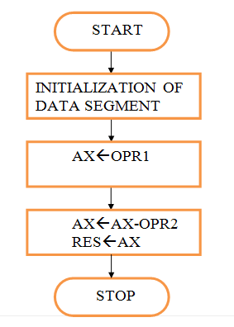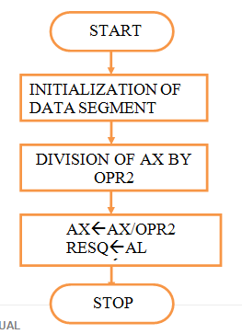

**____________________________________________________________**

**PROGRAMS** (using register addressing mode):

A. 16 BIT MULTIPLICATION

1 assume cs:code,ds:data

2

3 0000 data segment

4 0000 4444 n1 dw 4444h

5 0002 4567 n2 dw 4567h

6 0004 ???????? n3 dd ?

7 0008 data ends

8

9 0000 code segment

10

11 0000 start:

12 0000 B8 0000s mov ax,data

13 0003 8E D8 mov ds,ax

14

15 0005 A1 0000r mov ax,n1

16 0008 8B 1E 0002r mov bx,n2

17 000C F7 E3 mul bx

18 000E BE 0004r lea si,n3

19 0011 89 04 mov [si],ax

20 0013 89 54 02 mov [si+2],dx

21

22 0016 CC int 3

23

24 0017 code ends

25 end start

B. WORD BY BYTE DIVISION

1 assume cs:code,ds:data

2

3 0000 data segment

4 0000 0444 n1 dw 0444h

5 0002 45 n2 db 45h

6 0003 ???? n3 dw ?

7 0005 data ends

8

9 0000 code segment

10

11 0000 start:

12 0000 B8 0000s mov ax,data

13 0003 8E D8 mov ds,ax

14

15 0005 A1 0000r mov ax,n1

16 0008 8A 1E 0002r mov bl,n2

17 000C F6 F3 div bl

18

19 000E A3 0003r mov n3,ax

20 0011 BE 0003r lea si,n3

21

22 0014 CC int 3

23

24 0015 code ends

25 end start

**____________________________________________________________**

**RESULT:**

A. C. 16 BIT MULTIPLICATION

AX= CB5C & SI=0004 ; D 0000 0005 44 44 67 45 5C CB

B. WORD BY BYTE DIVISION

AX= 390F & SI=0003 ; D 0000 0004 44 04 45 0F 39

**____________________________________________________________**